**DEPLOY SIMPLE PYTHON WEB APPLICATION USING ELASTIC BEAN STALK IN AWS**

***A Summer Internship Report submitted in partial fulfillment of the***

***requirements for the award of degree of***

**BACHELOR OF TECHNOLOGY**

**In**

**CSE(AI&ML)**

## Submitted by

M.Mary Shakeena

22MH1A42H3



**ADITYA COLLEGE OF ENGINEERING & TECHNOLOGY (A)**

Approved by AICTE, Permanently affiliated to JNTUK & Accredited by NAAC with ‘A+’ Grade

**Recognized by UGC under the sections 2(f) and 12(B ) of the UGC Act 1956**

**Aditya Nagar, ADB Road –Surampalem 533437, East Godavari Dist.,A.P.**

**2024-2025**

**ADITYA COLLEGE OF ENGINEERING & TECHNOLOGY (A)**

Approved by AICTE, Permanently affiliated to JNTUK & Accredited by NAAC with ‘A+’ Grade

**Recognized by UGC under the sections 2(f) and 12(B ) of the UGC Act 1956**

**Aditya Nagar, ADB Road –Surampalem 533437, East Godavari Dist.,A.P.**



**CERTIFICATE**

This is to certify that the Internship report entitled *“***Deploy Simple Web Application using elastic bean in AWS Development***”*is being submitted by **M.MARY SHAKEENA(22MH1A42H3)**.In partial fulfillment of the requirements for the award of the B.Tech degree in **CSE(AIML)** for the academic year 2024-2025.

**InternshipCoordinator Head of the Department**

Guide Name: Mrs. K. Padmavathi DR. B. Kiran Kumar

Designation: Assistant Professor Assoc.Professor,

Department: CSE-AIML CSE-AIML/IoT

**DECLARATION**

I hereby declare that the Internship entitled **“Deploy Simple Python Web Application Using Elastic Bean Stalk in AWS”** is a genuine report. This work has been submitted to the **ADITYA COLLEGE OF ENGINEERING & TECHNOLOGY (A),** Surampalem, permanently affiliated to **JNTUK, KAKINADA** in partial fulfillment of the **B.Tech** degree**.**

I also hereby declare that this internship report not submitted in full or partial any other university for any degree.

**M.MARY SHAKEENA**

**22MH1A42H3**

**INSTITUTE VISION & MISSION**

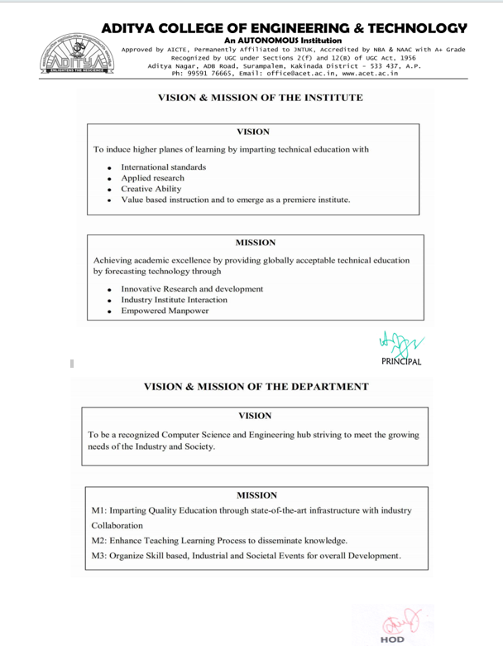

**INTERNSHIP COMPLETION CERTIFICATE**

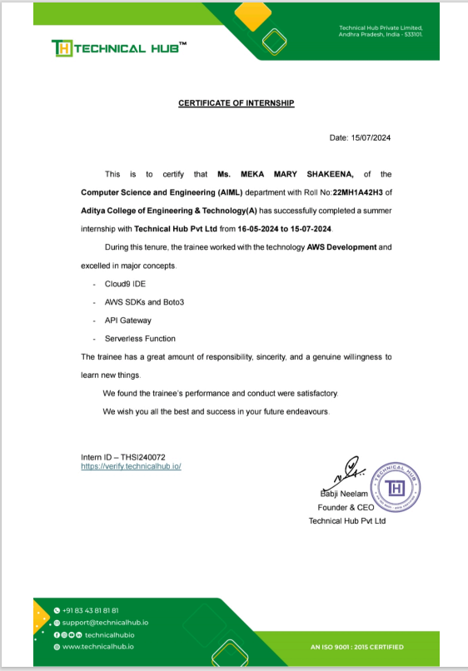

**ACKNOWLEDGEMENT**

I offer my sincere thanks to dynamic and beloved Principal, **Dr. A. Ramesh**, **Aditya College of Engineering & Technology(A)** for his co-operation.

My sincere thanks to **Dr. B. Kiran Kumar, M.Tech., Ph.D, Head of the department of CSE-Artificial Intelligence and Machine Learning** for his valuable support.

I express my sincere gratitude to my internship guide, **Mrs. K. Padmavathi, Assistant Professor, Department of CSE-Artificial Intelligence & Machine Learning**, for his/her valuable guidance and encouragement which has been helpful in successful completion of this internship.

With immense pleasure I would like to express my deep sense and heart full thanks to the management of Aditya College of Engineering & Technology (A).

**Learning Objectives/Internship Objectives**

**1.** Internships are generally thought of to be reserved for college students looking to gain experience in a particular field. However, a wide array of people can benefit from Training Internships in order to receive real world experience and develop their skills.

**2.** An objective for this position should emphasize the skills you already possess in the area and your interest in learning more

**3.** Internships are utilized in a number of different career fields, including architecture, engineering, healthcare, economics, advertising and many more.

**4.** Some internships are used to allow individuals to perform scientific research while others are specifically designed to allow people to gain first-hand experience working.

**5.**Utilizing internships is a great way to build your resume and develop skills that can be emphasized in your resume for future jobs. When you are applying for a Training Internship, make sure to highlight any special skills or talents that can make you stand apart from the rest of the applicants so that you have an improved chance of landing the position.

**ABSTRACT**

This report describes my internship at Technical Hub on AWS Development. Technical Hub is a leading IT company that provides internships to many engineering students in various domains such as Web Development, AI, Python, IoT, etc.

The scope of this document is to identify and describe the analysis carried out, projects completed, and experience gained, focusing on the achievements as an AWS Development Intern. Technical Hub provides a glorious opportunity and flexibility to their interns by offering internships online.

During the internship at Technical Hub, I was introduced to new technologies and languages. The most amazing experience was working with the team and completing their projects.Overall, I am very satisfied with the results of my internship. I was able to use AWS services, tools, and best practices and apply them to real-world problems. I observed notable differences in the functioning of tasks due to my contributions. Despite the short time period spent with Technical Hub, I took this experience as an opportunity to provide Technical Hub with the skills I learned as an AWS Development student at Aditya College of Engineering and Technology.

**Index**

|  |  |  |
| --- | --- | --- |
| **SI.No** | **CONTENT** | **PAGE No.** |
| **1.** | **Learning Objectives/Internship Objectives** | **7** |
| **2.** | **Abstract** | **8** |
| **3.** | **Chapter 1: Executive Summary** | **9** |
| **4.** | **Chapter 2: Overview of the Organization** | **10** |
| **5.** | **Chapter 3: Internship part** | **11-14** |
| **6.** | **Chapter 4: WEEKLY OVERVIEW OF INTERNSHIP ACTIVITIES** | **15-34** |
|  | Activity Log for The First Week  Weekly Report-First Week | **15-16** |
|  | Activity Log for The Second Week  Weekly Report-Second Week | **17-18** |
|  | Activity Log for The Third Week  Weekly Report-Third Week | **19-20** |
|  | Activity Log for The Fourth Week  Weekly Report-Fourth Week | **21-22** |
|  | Activity Log for The Fifth Week  Weekly Report-Fifth Week | **23-24** |
|  | Activity Log for The Sixth Week  Weekly Report-Sixth Week | **25-26** |
|  | Activity Log for The Seventh Week  Weekly Report-Seventh Week | **27-28** |
|  | Activity Log for The Eighth Week  Weekly Report-Eighth Week | **29-30** |
|  | Activity Log for The Nineth Week  Weekly Report-Nineth Week | **31-32** |
|  | Activity Log for The Tenth Week  Weekly Report-Tenth Week | **33-34** |
| **7.** | **Chapter 5: Outcomes Description** | **35** |
| **8.** | **Source Code** | **36-43** |
| **9.** | **Student self Evaluation of the short -term internship** | **44** |
| **10** | **Evaluation by the Supervisor of the Intern Organization** | **45** |
| **11.** | **Photos and videos** | **46-49** |

# CHAPTER 1: Executive Summary

# CHAPTER 2: Overview of the Organization

**Overview:**

The demand-supply gap scenario, exponential opportunities and dynamic challenges in the 21st century call for a change in our thinking on engineering practice and education. A transformation on the current engineering education is the need of the hour. Growth of new knowledge together with rapidly evolving technological skills, the skill to communicate across disciplines, the ability to lead team-centered projects, contextualized problem formulation, and hands-on experience are the present demands of the global industry. On contrary to the present demands, students churned out from engineering colleges are not equipped to meet the current industry needs due to the growing gap between engineering practice, education and research which requires a lot of concern. As a timely response, it is this concern for the student that has led Aditya to initiate Technical Hub: a perfect launch pad to the job world. Technical Hub trains students in various disciplines beyond technological labels besides equipping them with skills and creativity required for advancement in their careers. Through its various programs Technical Hub provides adequate opportunities for an unmatched knowledge base by imparting all necessary skills to students and makes them job ready.

Website : https://technicalhub.io/

Company size : 51-200 employees

Headquarters : Surampalem, Andhra Pradesh

Founded : 2016

**Specialties:**

Innovative Product Development, Recruitment, Business Software,. Educational Software, Virtual Reality, Machine Learning, Cyber Security, Digital Marketing, Android, Networking, Augmented Reality, Block Chain, Java, C, Gaming, Robotics, Machine Learning, IoT, Mean Stack, Python, Auto CAD, 3D Printing, and Drone Piloting

# CHAPTER 3: INTERNSHIP PART

# Description of the Activities/Responsibilities in the Intern Organization during Internship, which shall include - details of working conditions, weekly work schedule, equipment used, and tasks performed. This part could end by reflecting on what kind of skills the intern acquired.

# 

# WEEKLY OVERVIEW OF INTERNSHIP ACTIVITIES

**ACTIVITY LOG FOR THE FIRST WEEK**

|  |  |  |  |  |
| --- | --- | --- | --- | --- |
| **1stWEEK** | **Date** | **Day** | **Brief Description of Daily Activity** | **Learning Outcomes** |
| 16-05-2024 | Thursday | On-boarding and introduction to company | About company, scope of internship and mentor introduction |
| 17-05-2024 | Friday | Introduction to GitHub and Version Control System | Understanding concept of Version Control System using Git and GitHub |
| 18-05-2024 | Saturday | Introduction to Operating Systems | Understanding the concept of Operating Systems in Servers |

**WEEKLY REPORT**

WEEK – 1 (From Dt 16/05/2024 to Dt 18/05/2024)

**Objective of the Activity Done**: Version Control System & Operating Systems

**Detailed Report**:Since the technology of Cloud Computing requires knowledge of Operating Systems, the activity conducted based on OS concepts understood in Week-1. By doing this activity the I am able to define the benefits of Version Control System and basic and main functionalities of Operating Systems.

**ACTIVITY LOG FOR THE SECOND WEEK**

|  |  |  |  |  |
| --- | --- | --- | --- | --- |
| **2nd WEEK** | **Date** | **Day** | **Brief Description of Daily Activity** | **Learning Outcomes** |
| 20-05-2024 | Monday | Working with Different Operating Systems | Explore and work with Windows, Linux and Server versions of Operating Systems |
| 21-05-2024 | Tuesday | Introduction to Client-Server Architecture | Understanding the Client and Server Architecture in real-time environments |
| 22-05-2024 | Wednesday | Different types of Servers | Explore the usage and benefits of various servers such as Web, email, FTP, DHCP, FTP, SSH etc |
| 23-05-2024 | Thursday | Introduction to Networking | Understanding role of Networking and Communication in Datacenters and Cloud |
| 24-05-2024 | Friday | Datacenters and Servers | Exploring the Datacenter environment and infrastructure |
| 25-05-2024 | Saturday | Activity on infrastructure connectivity | Practical knowledge check on topics covered in the 1st & 2nd Week |

**WEEKLY REPORT**

WEEK – 2 (From Dt 20/05/2024 to Dt 25/05/2024)

**Objective of the Activity Done**: Understanding infrastructure connectivity

**Detailed Report:** In this activity, I was able to define and explore different types of servers and the way they connect to each other using IP Networking concepts. By the end of this activity, it is clearly understood that Client-Server architecture works, how the servers in datacenters placed and infrastructure of the cloud environment that is created by connecting multiple datacenters from different locations of the world

**ACTIVITY LOG FOR THE THIRD WEEK**

|  |  |  |  |  |
| --- | --- | --- | --- | --- |
| **3rdWEEK** | **Date** | **Day** | **Brief Description of Daily Activity** | **Learning Outcomes** |
| 27-05-2024 | Monday | Introduction to Cloud Infrastructure | Understanding how the data centers connect in real-time |
| 28-05-2024 | Tuesday | Cloud Computing Models | Explore Cloud computing models as per NIST |
| 29-05-2024 | Wednesday | Cloud Services | Understanding Cloud services as per NIST |
| 30-05-2024 | Thursday | Introduction To Virtualization | Exploring how the traditional computing transitioned to Virtualization |
| 31-05-2024 | Friday | Virtual Severs of Linux | Understanding how the servers created in Virtual Environment |
| 01-06-2024 | Saturday | Activity on Cloud and Virtualization | Practical knowledge check on topics covered until Week-3 |

**WEEKLY REPORT**

WEEK – 3 (From Dt 27/05/2024 to Dt 01/06/2024)

**Objective of the Activity Done**: Cloud and Virtualization

**Detailed Report**: This activity is based on understanding the concepts covered as per Virtualization. By the end of this activity, I was able to explore how the traditional Operating Systems and infrastructure transitioned to virtual environment. It is also understood that virtualization is the pillar of cloud computing concept and how the cloud is built using the various concepts of virtualization.

The infrastructure virtualization is the core concept behind cloud computing that give the customers to manage their resources flexibly considering High Availability, Scalability, Security and Reliability concepts of various server types and cloud services.

**ACTIVITY LOG FOR THE FORTH WEEK**

|  |  |  |  |  |
| --- | --- | --- | --- | --- |
| **4thWEEK** | **Date** | **Day** | **Brief Description of Daily Activity** | **Learning Outcomes** |
| 03-06-2024 | Monday | Introduction to Linux OS | Understanding why Linux is everywhere |
| 04-06-2024 | Tuesday | Holiday | Holiday (AP Election Results) |
| 05-06-2024 | Wednesday | Linux command syntax and basic commands | Understand the usage of Linux command syntax |
| 06-06-2024 | Thursday | Linux User and Groups | Explore different types of users and groups in Linux |
| 07-06-2024 | Friday | Basic file and directory permission in Linux | Exploring how the permissions work for file, directories, users & Groups |
| 08-06-2024 | Saturday | Activity on Linux Operating System | Practical knowledge check on topics covered until Week-4 |

**WEEKLY REPORT**

WEEK – 4 (From Dt 03/06/2024 to Dt 08/06/2024)

**Objective of the Activity Done**: Working with Linux Operating system

**Detailed Report:** Linux Operating System is considered as a one of the best Open-Source platforms deployed on most the server applications used today. Because of the flexibility of using the applications with integrated security options in Linux, this OS became a widely used platform preferred by major application providers in the world.

By the end of this activity I explore the command syntax of Linux Operating System, OS file system and hierarchy, working with files and directories, applying file and directory level permissions, creating users and working with different types of editors etc.

**ACTIVITY LOG FOR THE FIFTH WEEK**

|  |  |  |  |  |
| --- | --- | --- | --- | --- |
| **5thWEEK** | **Date** | **Day** | **Brief Description of Daily Activity** | **Learning Outcomes** |
| 10-06-2024 | Monday | Introduction to AWS Services and Service Categories | Understanding AWS offered services and its categories |
| 11-06-2024 | Tuesday | Understanding AWS Management Console | Explore AWS Management console using sandbox |
| 12-06-2024 | Wednesday | AWS Regions and Availability Zones | Explore and Switch between AWS Regions |
| 13-06-2024 | Thursday | Introduction to AWS Compute Services | Understanding AWS Compute service EC2 and related components |
| 14-06-2024 | Friday | Working with EC2 Service | Exploring various launching options of EC2 |
| 15-06-2024 | Saturday | Activity on AWS Management Console and EC2 Service | Practical knowledge check on topics covered until Week-5 |

**WEEKLY REPORT**

WEEK – 5 (From Dt 10/06/2024 to Dt 15/06/2024)

**Objective of the Activity Done**: AWS Management console and EC2 Service

**Detailed Report:** Since we understood the cloud infrastructure, Operating Systems, Server-Client and Linux OS concepts, we tried launching the server in AWS Cloud named EC2 instance using AWS Management console. By the end of this activity, I am able to explore and understand how the virtual server can be launched using AWS Cloud and connect to it using various connectivity methods.

It is clear that how the EC2 instances can be connected to on-premises to copy and migrate the data from on-premises servers to cloud instances.

**ACTIVITY LOG FOR THE SIXTH WEEK**

|  |  |  |  |  |
| --- | --- | --- | --- | --- |
| **6thWEEK** | **Date** | **Day** | **Brief Description of Daily Activity** | **Learning Outcomes** |
| 17-06-2024 | Monday | Holiday | Holiday (Bakrid) |
| 18-06-2024 | Tuesday | Web application deployment on Windows Server | Deploying sample web application on Windows EC2 server |
| 19-06-2024 | Wednesday | EC2Web application deployment on Linux Server | Deploying sample web application on Ubuntu and Amazon EC2 server |
| 20-06-2024 | Thursday | EC2 Managing options for EC2 instance | EC2 managing options such as stop, start, terminate etc. |
| 21-06-2024 | Friday | Ways of connecting to Linux EC2 instances using SSH. Sharing data between local and cloud EC2 instances | Exploring different ways of securely connecting to EC2 instance |
| 22-06-2024 | Saturday | Activity on web application deployment using EC2 compute service | Practical knowledge check on topics covered until Week-6 |

**WEEKLY REPORT**

WEEK – 6 (From Dt 17/06/2024 to Dt 22/06/2024)

**Objective of the Activity Done**: Web application deployment in cloud servers

**Detailed Report:** Deploying the applications in cloud is an easy and flexible task after understanding the EC2 instance concepts. I obtain practical knowledge on how the applications will be deployed in cloud instances and can be accessed using security groups created.

In this activity, I launched Linux and Windows server instances and deployed various kinds of web applications. Used the security groups to allow and deny access to some of the ports and IP Addresses.

**ACTIVITY LOG FOR THE SEVENTH WEEK**

|  |  |  |  |  |
| --- | --- | --- | --- | --- |
| **7thWEEK** | **Date** | **Day** | **Brief Description of Daily Activity** | **Learning Outcomes** |
| 24-06-2024 | Monday | Introduction to Storage technologies | Explore and understand various storage technologies |
| 25-06-2024 | Tuesday | Block vs Object Storage serives | Understanding difference between Block and Object storage |
| 26-06-2024 | Wednesday | Working with AWS S3 | Understanding S3 buckets and objects |
| 27-06-2024 | Thursday | Volumes and Snapshots using AWS Elastic Block Storage | Exploring EBS volume and snapshot concepts |
| 28-06-2024 | Friday | Working with EBS Snapshots | Create, Delete and reconnect EBS volume snapshots |
| 29-06-2024 | Saturday | Activity on AWS Object and Block Storage | Practical knowledge check on topics covered until Week-7 |

**WEEKLY REPORT**

WEEK – 7 (From Dt 24/06/2024 to Dt 29/06/2024)

**Objective of the Activity Done**: Working with AWS Object and block storage services

**Detailed Report**: Data backup and recovery is vital process in server management. Backing up the data and volumes of servers in proper scheduling makes the task of Disaster Recovery an easier one. In this activity, explored on AWS Block storage service that allows the customer to take snapshots of volumes easily for backup purposes.

Also, deployed the static website using AWS S3 object storage service that is an unlimited storage service offered.

**ACTIVITY LOG FOR THE EIGHTH WEEK**

|  |  |  |  |  |
| --- | --- | --- | --- | --- |
| **8thWEEK** | **Date** | **Day** | **Brief Description of Daily Activity** | **Learning Outcomes** |
| 01-07-2024 | Monday | Introduction to AWS Networking Service | Understanding AWS VPC Service |
| 02-07-2024 | Tuesday | AWS Virtual Private Cloud and its components | Explore Subnet and Routing table components of AWS VPC |
| 03-07-2024 | Wednesday | IPv4 Addressing and Subnetting | Understanding IPv4 vs IPv6. Subnetting IPv4 Addressing |
| 04-07-2024 | Thursday | Launching and Connecting resources in AWS VPC | Exploring AWS VPC by launching and connecting resources in it |
| 05-07-2024 | Friday | Web deployment using AWS Elastic Beanstalk | Understanding serverless deployment using AWS Elastic Beanstalk |
| 06-07-2024 | Saturday | Activity on AWS VPC and Elastic Beanstalk | Practical knowledge check on topics covered until Week-8 |

**WEEKLY REPORT**

WEEK – 8 (From Dt 01/07/2024 to Dt 06/07/2024)

**Objective of the Activity Done**: AWS VPC and Elastic Beanstalk

**Detailed Report**: Deployed the sample web application using serverless technology. Elastic Beanstalk is the serverless service offered by AWS to deploy web applications on the go without focusing much on virtual infrastructure. This service comes under the category of Platform as a Service (PaaS).

Created an isolated network in cloud that is Virtual Private Cloud, as network service offered by AWS to create networks within regions. Launched the ec2 server resources in VPC and used concepts of Subnet, Internet Gateway, Routing Tables etc to connect successfully to these services.

**ACTIVITY LOG FOR THE NINTH WEEK**

|  |  |  |  |  |
| --- | --- | --- | --- | --- |
| **9thWEEK** | **Date** | **Day** | **Brief Description of Daily Activity** | **Learning Outcomes** |
| 08-07-2024 | Monday | Introduction to Development on AWS | Exploring development services in AWS |
| 09-07-2024 | Tuesday | Working with AWS Cloud Shell, AWS CLI & AWS Cloud9 IDE | Understanding CLI access and AWS Cloud9 IDE environments |
| 10-07-2024 | Wednesday | Static website deployment in AWS S3 using Python for AWS SDK (boto3) | Understanding how to deploy the AWS services using boto3 |
| 11-07-2024 | Thursday | Secure access to cloud resources using AWS Identity and Access Management | Understanding how the access to cloud resources can be controlled using AWS IAM |
| 12-07-2024 | Friday | Working with AWS NoSQL services and AWS DynamoDB | Differentiate between SQL and NoSQL databases and explore on NoSQL based AWS DynamoDB service |
| 13-07-2024 | Saturday | Project Deployment | Hand-on project with use case applying knowledge of all topics covered until Week-9 |

**WEEKLY REPORT**

WEEK – 9 (From Dt 08/07/2024 to Dt 13/07/2024)

**Objective of the Activity Done**: Working with AWS Development Services

Detailed Report: After going through the development services available in AWS, able to work with then by deploying and creating web applications and databases in cloud.

Worked with AWS SDK, AWS Cloud9, AWS CLI and AWS Code Whisperer to deploy the applications and database services. Used AWS SDK for Python that is also known as boto3 in AWS to deploy the static website in s3.

Configured the users and groups to access resources securely using IAM service. Used the NoSQL based AWS DynamoDB service to create tables and items related to web applications.

**ACTIVITY LOG FOR THE TENTH WEEK**

|  |  |  |  |  |
| --- | --- | --- | --- | --- |
| **10thWEEK 9thWEEK** | **Date** | **Day** | **Brief Description of Daily Activity** | **Learning Outcomes** |
| 15-07-2024 | Monday | Project Deployment | Hand-on project with use case applying knowledge of all topics covered until Week-9 |

**WEEKLY REPORT**

WEEK – 10 From Dt 13/07/2024 to Dt 15/07/2024)

**Objective of the Activity Done:**

The primary objectives for the eighth week were to finalize the project, ensure its performance and reliability, and complete the submission process. This week aimed to make final adjustments, verify the project's compliance with requirements, and submit the completed project.

**Detailed Report:**

On Monday, the focus was on making final changes to the project. This included addressing any last-minute adjustments and improvements to ensure the project met all specifications and requirements. The goal was to polish the project and prepare it for the final stages of evaluation and submission.

Tuesday's activities were dedicated to ensuring the performance of the project. This involved checking various aspects of the project to ensure reliability and effectiveness.

On Wednesday, I continued with checking of the project to make sure it met all the requirements to ensure the project's optimal functionality. The focus was on refining the project and ensuring it met all performance criteria.

Thursday's activities involved a final verification of the project. This verification process was crucial for confirming the project's readiness for submission and ensuring that all deliverables were complete and accurate.

On Friday, I completed the project submission process. This involved finalizing all documentation, preparing deliverables, and submitting the project according to the specified guidelines. The submission marked the conclusion of the project work and demonstrated the successful completion of the project objectives.

**CHAPTER 5: Outcomes Description**

**Work Environment Experience**

During my internship at Technical Hub, I experienced a work environment that was both professional and supportive, tailored to foster both individual and team growth.

**People Interactions**: Interactions with colleagues and supervisors were positive and collaborative. The team was approachable, with frequent opportunities for one-on-one discussions, feedback, and mentoring. There was a strong culture of mutual respect, where everyone was encouraged to share ideas and seek assistance when needed.

**Discipline and Time Management**: Discipline was emphasized through a structured work schedule and regular check-ins. Time management was a key focus, with daily stand-up meetings and weekly progress reviews helping to keep projects on track. The balance between task deadlines and project milestones was well-managed, allowing for efficient progress.

**Protocols, Procedures, and Processes**: The organization followed well-established protocols and procedures, especially in areas related to network security and project management. There was a structured approach to task execution, including documented processes for configuring VPCs, implementing NAT gateways, and integrating OpenVPN. This structure ensured consistency and quality in all work performed.

**Mutual Support and Teamwork**: Teamwork was a fundamental aspect of the internship. Colleagues readily offered support and collaborated on various aspects of network design and implementation. The emphasis on mutual support enhanced problem-solving and innovation, contributing to successful project outcomes.

In summary, the work environment at Technical Hub was designed to support a productive and positive internship experience. The combination of effective people interactions, well-maintained facilities, clear job roles, structured processes, and a supportive culture contributed significantly to my overall learning and professional development.

**1.Introduction:**

AWS (Amazon Web Services): Amazon Web Services (AWS) is a comprehensive cloud computing platform offered by Amazon. It provides a broad range of cloud-based services, including:

1) Computing Power: Services like Amazon EC2 (Elastic Compute Cloud) allow users to run virtual servers and manage scalable computing resources.

2) Storage: Services such as Amazon S3 (Simple Storage Service) offer scalable and durable storage solutions.

3) Databases: Managed database services like Amazon RDS (Relational Database Service) support various database engines.

4) Networking: AWS includes services for networking and content delivery, such as Amazon VPC (Virtual Private Cloud) and CloudFront.

5) Machine Learning: AWS provides tools for machine learning and artificial intelligence, including Amazon Sage Maker.

AWS is known for its scalability, flexibility, and global infrastructure, making it a popular choice for businesses of all sizes to build, deploy, and manage applications and services.

**2. AWS History:**

Amazon Web Services (AWS) has a rich history marked by significant milestones:

1) 2002: AWS was officially launched with the release of Amazon's first web services, including Amazon S3 (Simple Storage Service) and Amazon EC2 (Elastic Compute Cloud). These initial services aimed to provide scalable storage and computing capabilities over the internet.

2) 2006: The introduction of Amazon EC2 marked a significant development in cloud computing, allowing users to rent virtual servers on-demand. This innovation played a crucial role in the evolution of cloud infrastructure.

3) 2008: AWS introduced Amazon S3's “Availability Zones,” improving reliability and fault tolerance by distributing data across multiple data centers within a region.

4) 2010: The launch of AWS Elastic Beanstalk provided a platform-as-a-service (PaaS) solution, simplifying the deployment and management of applications.

5) 2014: AWS announced Amazon Aurora, a high-performance, MySQL-compatible relational database engine. This year also saw the introduction of Amazon Lambda, which pioneered serverless computing by allowing users to run code without provisioning or managing servers.

6) 2016: AWS made significant strides with the introduction of Amazon Polly (text-to-speech) and Amazon Rekognition (image and video analysis), expanding its suite of artificial intelligence and machine learning services.

7) 2018: AWS reached a major milestone with the opening of its AWS Outposts, allowing customers to extend AWS infrastructure and services to on-premises locations, blending cloud and on-premises environments.

8. 2021: AWS expanded its global infrastructure with new regions and availability zones, reinforcing its commitment to global presence and low-latency services.

# 3. Definition of AWS:

# AWS (Amazon Web Services) is a comprehensive cloud computing platform provided by Amazon. It offers a wide range of services, including computing power, storage, and databases, delivered on-demand to businesses and individuals. AWS enables scalable and flexible IT infrastructure through its global network of data centers. It supports a variety of workloads, from web applications to machine learning. With a pay-as-you-go pricing model, AWS allows users to optimize costs and resources effectively.

# 4.Deploying a Python Web Application Using AWS Elastic BeanStalk

AWS Elastic Beanstalk is a versatile Platform-as-a-Service (PaaS) provided by Amazon Web Services (AWS). It simplifies the deployment, management, and scaling of web applications by handling much of the underlying infrastructure management. This allows developers to focus on building and refining their applications without worrying about server management, scaling issues, or load balancing.

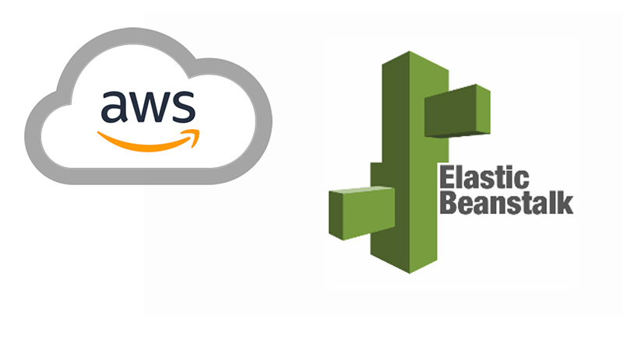

**Key Components:**

* **Application**: This represents the collection of code and related configuration files that make up your web application. Elastic Beanstalk allows you to manage different versions of your application and deploy them as needed.
* **Environment**: Each environment is a separate deployment of your application. Environments can be used for various stages of development, such as development, testing, and production. They are fully configurable to meet the specific needs of each stage.
* **Platform**: Elastic Beanstalk supports multiple platforms, including Python. A platform provides the runtime environment that your application runs on. For Python, it includes the necessary runtime and web server software to execute your application.

**6.Deploying Your Application**:

**Preparing Deployment**:

Before deploying, package your application into a format compatible with Elastic Beanstalk, typically a ZIP file. This package should include all necessary files, such as application scripts and dependency lists.

**Deployment Process**:

Deploy your application using the Elastic Beanstalk console, AWS CLI, or EB CLI. Elastic Beanstalk will handle the deployment process, including:

* **Provisioning Resources**: Allocating the necessary infrastructure, such as virtual servers and databases.
* **Configuring Services**: Setting up services required by your application, including load balancers and auto-scaling groups.
* **Deploying Code**: Installing your application code and dependencies on the provisioned resources.

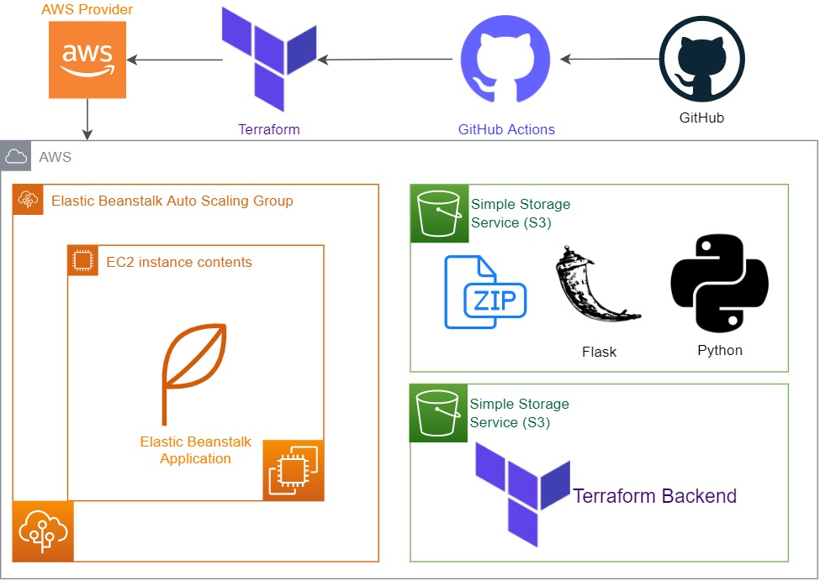

**7.Monitoring and Managing Your Application:**

**7.1 Log Management**

Elastic Beanstalk provides integrated logging capabilities, allowing you to access and view logs related to application performance and errors. This is essential for diagnosing issues and ensuring your application runs smoothly.

**7.2 Health Monitoring**

Monitor the health of your application through the Elastic Beanstalk console. The service provides real-time insights into application performance, including metrics on resource usage, error rates, and application response times. This helps you proactively manage and address any issues that arise.

**7.3 Updating Your Application**

To update your application, simply deploy a new version of your application package. Elastic Beanstalk handles the update process, which includes replacing the old version with the new one while minimizing downtime.

**7.4 Ongoing Maintenance**

Regularly maintain your application environment by applying updates and patches. Monitor for performance issues and security vulnerabilities, and adjust configurations as necessary to ensure optimal performance and security.

**8. Benefits of AWS Elastic Beanstalk:**

**8.1 Managed Infrastructure**

Elastic Beanstalk automates many aspects of infrastructure management, such as provisioning, scaling, and load balancing. This reduces the need for manual intervention and allows developers to focus on building and improving their applications.

**8.2 Simplified Deployment**

The deployment process is streamlined with Elastic Beanstalk’s management tools and interfaces. Developers can deploy applications with minimal configuration, making it easier to get applications up and running quickly.

**8.3 Scalability**

Elastic Beanstalk automatically scales your application based on traffic and load. This ensures that your application remains responsive and available during peak usage periods, without requiring manual intervention.

**8.4 Integration with AWS Services**

Elastic Beanstalk integrates seamlessly with other AWS services, such as RDS for databases, S3 for storage, and CloudWatch for monitoring. This provides a cohesive and comprehensive environment for managing and operating web applications.

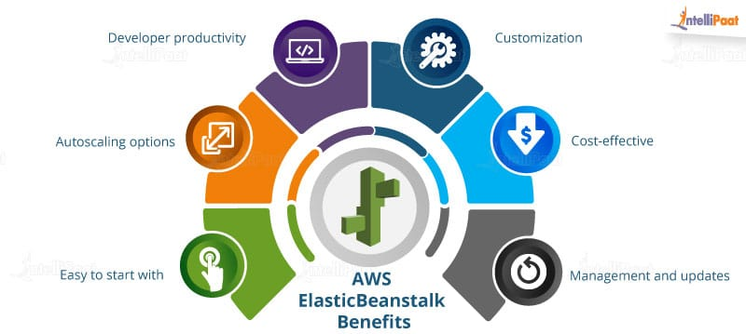

**Student Self Evaluation of the Short-Term Internship**

**Student Name:** M.Mary Shakeena

**Registration No:** 22MH1A42H3

**Duration of Internship:**

**From: To:**

**Date of Evaluation:**

**Organization Name & Address**:

Please rate your performance in the following areas:

**Rating Scale: Letter grade of CGPA calculation to be provided**

|  |  |  |  |  |  |  |
| --- | --- | --- | --- | --- | --- | --- |
| 1 | Oral communication | 1 | 2 | 3 | 4 | 5 |
| 2 | Written communication | 1 | 2 | 3 | 4 | 5 |
| 3 | Interaction ability with community | 1 | 2 | 3 | 4 | 5 |
| 4 | Positive Attitude | 1 | 2 | 3 | 4 | 5 |
| 5 | Self-confidence | 1 | 2 | 3 | 4 | 5 |
| 6 | Ability to learn | 1 | 2 | 3 | 4 | 5 |
| 7 | Work Plan and organization | 1 | 2 | 3 | 4 | 5 |
| 8 | Quality of work done | 1 | 2 | 3 | 4 | 5 |
| 9 | Time Management | 1 | 2 | 3 | 4 | 5 |
| 10 | Achievement of Desired Outcomes | 1 | 2 | 3 | 4 | 5 |
| **OVERALL PERFORMANCE** | |  |  |  |  |  |

M.Mary Shakeena

Student Signature

**Evaluation by the Supervisor of the Intern Organization**

**Student Name:** M.Mary Shakeena

**Registration No:** 22MH1A42H3

**Duration of Internship:** 10 Weeks

**From: To:**

**Date of Evaluation:**

**Organization Name & Address**:

**Name & Address of the Supervisor with Mobile Number**

Please rate the student’s performance in the following areas:

Please note that your evaluation shall be done independent of the Student’s selfevaluation

**Rating Scale: 1 is lowest and 5 is highest rank**

|  |  |  |  |  |  |  |
| --- | --- | --- | --- | --- | --- | --- |
| 1 | Oral communication | 1 | 2 | 3 | 4 | 5 |
| 2 | Written communication | 1 | 2 | 3 | 4 | 5 |
| 3 | Interaction ability with community | 1 | 2 | 3 | 4 | 5 |
| 4 | Positive Attitude | 1 | 2 | 3 | 4 | 5 |
| 5 | Self-confidence | 1 | 2 | 3 | 4 | 5 |
| 6 | Ability to learn | 1 | 2 | 3 | 4 | 5 |
| 7 | Work Plan and organization | 1 | 2 | 3 | 4 | 5 |
| 8 | Quality of work done | 1 | 2 | 3 | 4 | 5 |
| 9 | Time Management | 1 | 2 | 3 | 4 | 5 |
| 10 | Achievement of Desired Outcomes | 1 | 2 | 3 | 4 | 5 |
| **OVERALL PERFORMANCE** | |  |  |  |  |  |

**Signature of the Supervisor**

**PHOTOS & VIDEO LINK**

